CSC387 Lab 05- NAT

# Instructions

In this lab, you’ll show your mastery of NAT! We have multiple networks with the same internal scheme, limited public IPs, and servers that need to be reached.

The following should be completed on Packet Tracer. Please take a screen shot of each of the Verification Steps (below) and submit in a labeled single word document using the screenshot guide in the class content on D2L. Make sure your device names are visible in the screen shot! Don’t forget to save your Packet Tracer file.

## Network Diagram

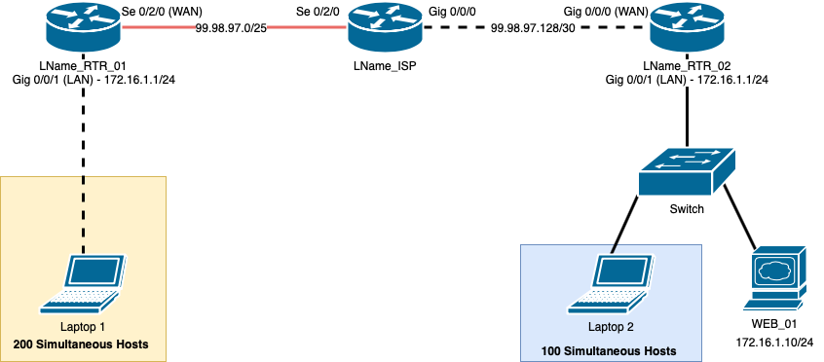

Configuration Tasks

Cable the network as shown in the above network diagram using 4331 routers and a 2960 switch in Packet Tracer. To enable Se 0/2/0 on the ‘Physical’ tab of each router, you will need to drag the NIM-2t module to the far-right open slot. Everything else that is over Ethernet is for you to do.

1. Configure each router with a hostname. In the diagram, replace the **LName** portion with your actual last name.
2. Set the. IP addresses on each router with the following guidelines:

### RTR_01

* + 1. Gig 0/0/1 will use the IP/subnet shown on the diagram.

ii. Se 0/2/0 will use the **99.98.97.2/25** IP.

iii. Configure the laptop to be on the appropriate subnet. You can do this through DHCP or static configuration.

### ISP

i. Se 0/2/0 will use the **99.98.97.1/25** IP.

ii. Gig 0/0/0 will use the **99.98.97.129/30** IP.

### RTR_02

i. Gig 0/0/0 will use the **99.98.97.130/30** IP.

1. Gig 0/0/1 uses the IP address shown on the network diagram.
2. Set WEB_01 to have the static IP address of **172.16.1.10**.
3. Configure the laptop to be on the appropriate subnet. You can do this through DHCP or static configuration. It can’t use **172.16.1.10**.

## Routing

Both RTR_01 and RTR_02 have a single path out to the internet – they are stub networks. Create a default route on each of those routers that uses the WAN interface as the exit interface.

Verification Step 1

## NAT

Since RTR_01 and RTR_02 have the same internal subnet scheme and the subnets are not publicly routable, they’ll need NAT.

### RTR_01

Your ISP has given you a big pool of IP public IP addresses to use.

1. Choose to configure Dynamic NAT or PAT. Look carefully at the diagram to see how many hosts need to be online at one time and make the best choice.
2. Once you’ve made your choice, configure your NAT implementation of with the following guidelines:
   1. Pool Name: **LName_NAT_Pool** (replace LName with your last name)
   2. Access List:
      1. Number: **20**
      2. Traffic Rule: **permit**
      3. Address to Match: **172.16.1.0**
      4. Wildcard Bits: whatever is appropriate for a /24 .

### RTR_02

Verification Step 2

Verification Step 3

This router has a couple of different requirements. It needs to allow Internet users to access the web server on port 80 and 443.Additionally, it needs to let its local users get out to the Internet.

1. Create static NAT mappings for:

a. 99.98.97.130:80 ➔ 172.16.1.10:80

b. 99.98.97.130:443 ➔ 172.16.1.10:443

1. Your internal hosts will get out to the internet by using PAT. Configure it with the following guidelines:
   1. Don’t use a NAT pool. Make the NAT mapping go to the **gig 0/0/0** interface instead.
   2. Access List:
      1. Number: **20**
      2. Traffic Rule: **permit**
      3. Address to Match: **172.16.1.0**
      4. Wildcard Bits: whatever is appropriate for a /24.

Verification Step 4

Verification Step 5

## Verification Steps

1. 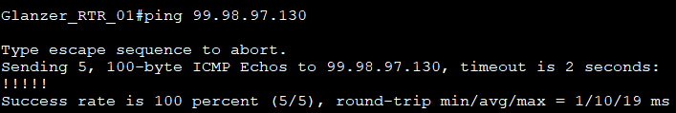With the default routes set up, RTR_01 should be able to ping RTR_02 successfully.
2. 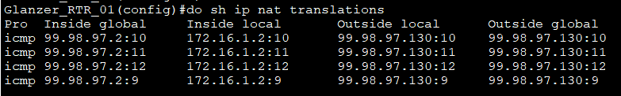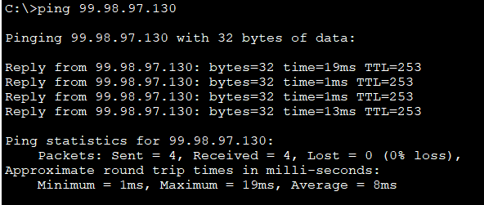Once your NAT is set up on RTR_01, Laptop 1 should be able to ping RTR_03 at **99.98.97.130**. If that is successful run the command **show ip nat translations** on RTR_01 and take a screenshot of the translation.
3. On RTR_01, do a **show run** and take a single screenshot that shows the commands that start with:
   1. ip nat pool
   2. ip nat inside
   3. access-list
4. 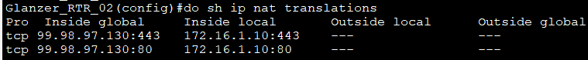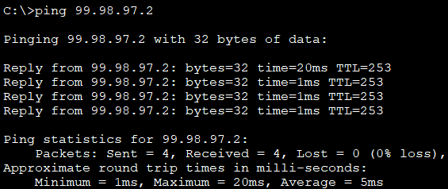Ping from Laptop 2 to RTR_01.If that is successful, do a **show ip nat translations** and take a screenshot of your NAT table.You should see the laptop’s translations through PAT and the static mappings for the web server.
5. 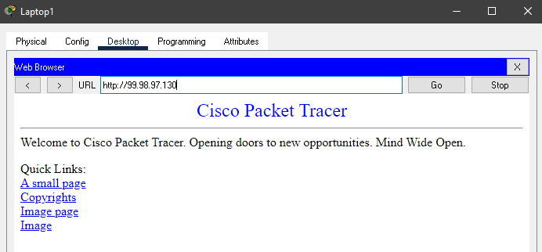Browse to the webserver at [http://99.98.97.130](http://99.98.97.130/) from Laptop 1. If the webpage opens, take a screenshot.

# What to Turn In

Go through each of the verification steps and take a screenshot. Please try to show each step in a single, clear screenshot to cut down the number of images. Also, paste all screenshots into a single Word/PDF document. Do not upload them to D2L as individual images – I won’t grade them.